VENICE LUXURY GUIDE

VENICE AND ITS EMPIRE IN THE NORTHERN ADRIATIC SEA

Helicopter and car tour - full day service inclusive of guide water and ground services

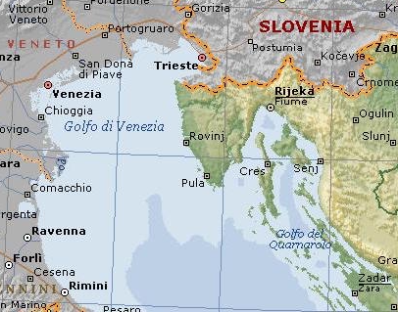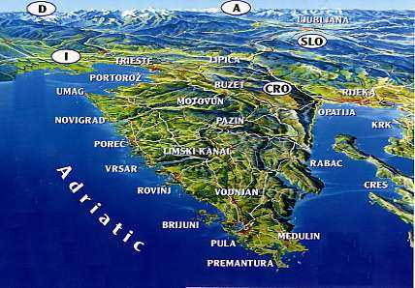

Long before the year 1000 CE when Venice began the adventurous conquest of the eastern shores of the Adriatic Sea, the roman and byzantine heritage of centuries of civilization had left behind memorable evidences.

Venice made the shores of the peninsula of Istria and of Dalmatia a second home for its culture for hundreds of years, along with the more southern albanian and greek territories.

The Adriatic sea soon became the Gulf of Venice, as the old maps still do show us in their accurate design of this coastline, along which the most incredible wealth of the ancient world was taken home, on board of vessels eventually sailing up the Grand Canal.

Some of the greatest venetians were actually born oversea: Carpaccio, Marco Polo, Tartini.

Venetian architecture of the gothic and renaissance period still dominates the cities and beautiful buildings do offer a crucial piece of comparison with the Serenissima unique beauty.

This tour is meant to expand your comprehension of the current “limited” venetian experience flying you into the glorious past of the byzantine origins and the opulent time of the merchants golden age along Istria and Dalmazia

From each landing port a car service will be at disposal to take you to the heart of this unique historical experience that went down in history as the Venetian Empire.

RAVENNA 25 minutes flight

Ravenna has been Roman, Gothic, Byzantine and also medieval, Venetian and finally modern

1600 years ago became a capital city three times; of the western Roman empire, of Theodoric King of the Goths and of the Byzantine empire in Europe.
The magnificence of this period has left Ravenna with a great heritage of historical buildings. There are no less than eight buildings declared World Heritage by UNESCO.
The art of mosaics did not originate in Ravenna but its greatest expression is to be found here. It was here that Christian iconology originated, a mixture of symbolism and realism, of Roman and Byzantine influence.

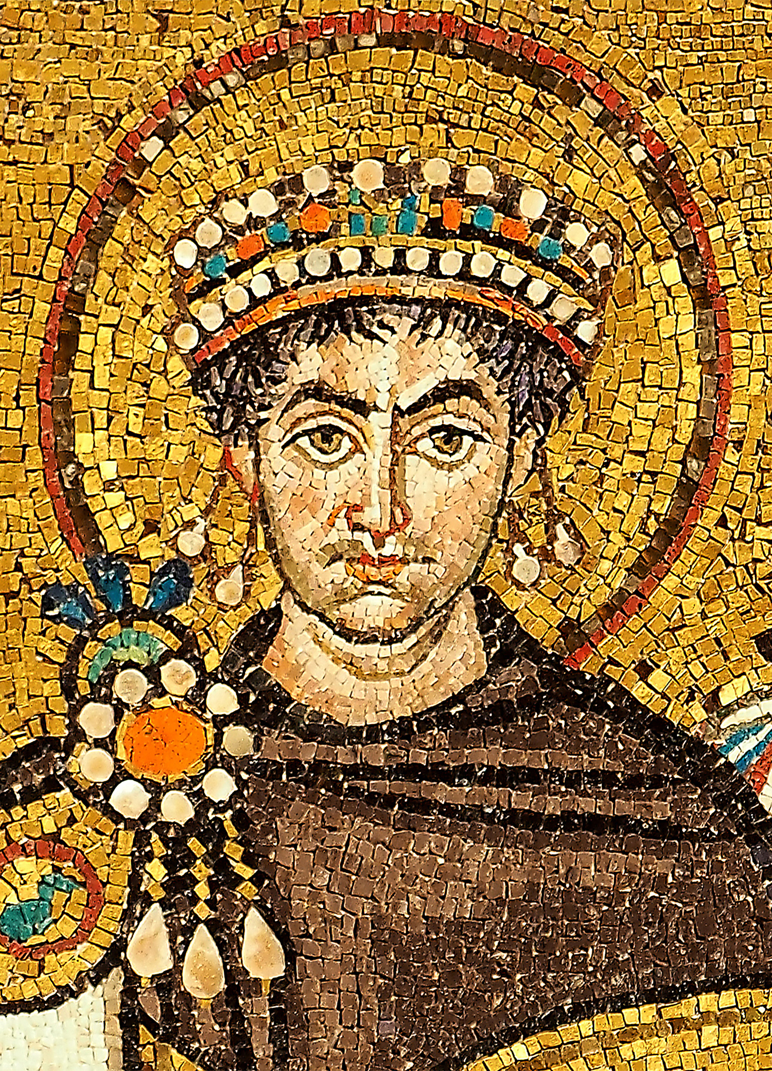

Pula /POLA 35 minutes flight

Pola is a city that has existed for 3000 years south of the Istrian peninsula. The town has beautiful beaches spread over nearly one hundred miles of beautiful and indented coastline.

The city-museum will present you with its buildings and monuments preserved from bygone times: the Arch of the Sergi, Temple of Augustus, Hercules door, the Arena.

The view of the Pula region is framed by the Brijuni National Park

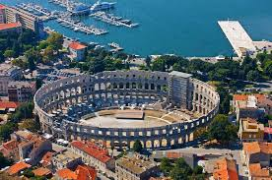

Poreč / PARENZO car service

Parenzo is byzantine - venetian town located in the heart of the western coast of Istria.

Traces of the past are preserved in the old part. The stone streets, the remains of ancient temples, forums and other beautiful buildings preserved from ancient times testify to the many rulers.
The Euphrasian basilica from the 6th century is the most valuable cultural and historical monument in Istria, and on the UNESCO World Heritage List.

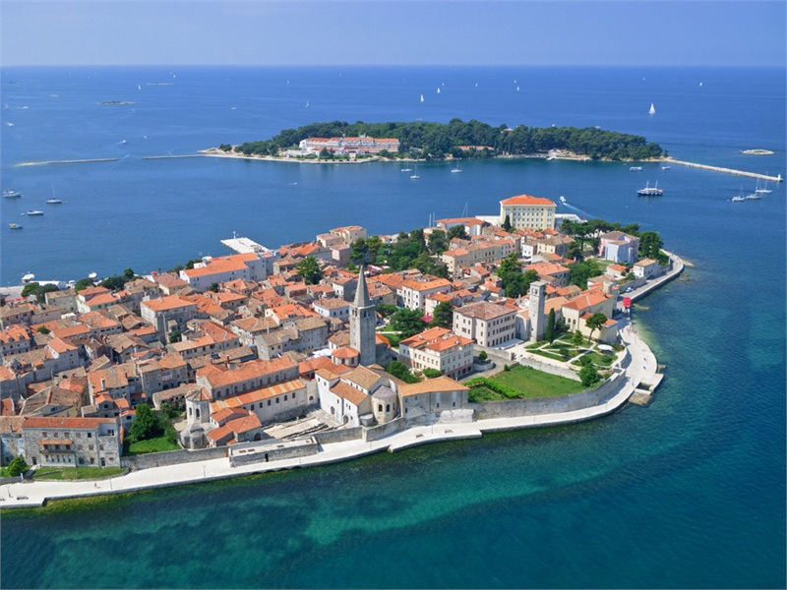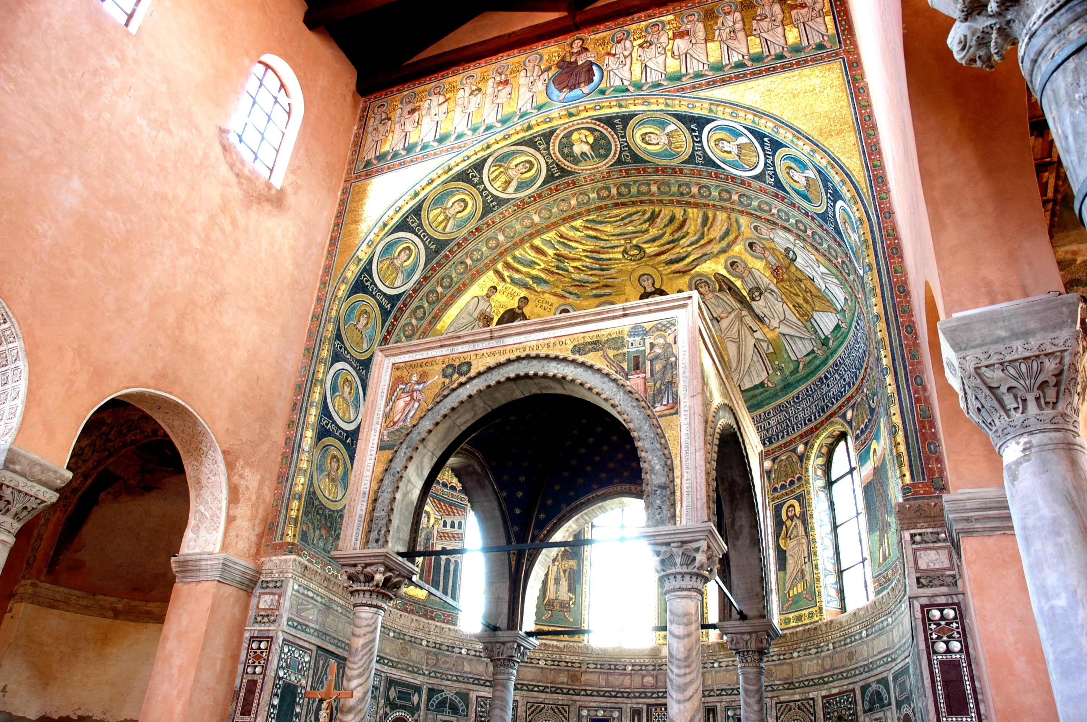

Rovinj / ROVIGNO car service

Rovigno is considered to be one of the most beautiful towns on the ancient venetian empire because of its unique appearance and its wonderful natural surroundings. The 67 kilometre long coast, 2,289 hectares of protected greenery, 14 islands, islets and rocks as well as a unique ancient town centre, make Rovinj unique.

The town of experiences, Venetian architecture and harmonious colours,

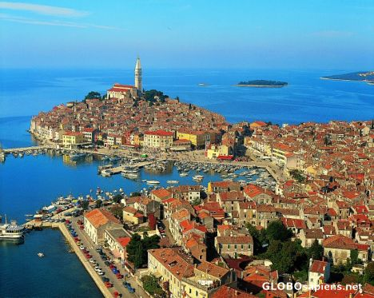

PIRANO 35 minutes flight

Pirano is one of the most photogenic cities of the venetian civilization, and it has preserved its unsurpassed charm.

The proximity to the sea and the rich history, which is mirrored in the architecture, draw magical scenes.

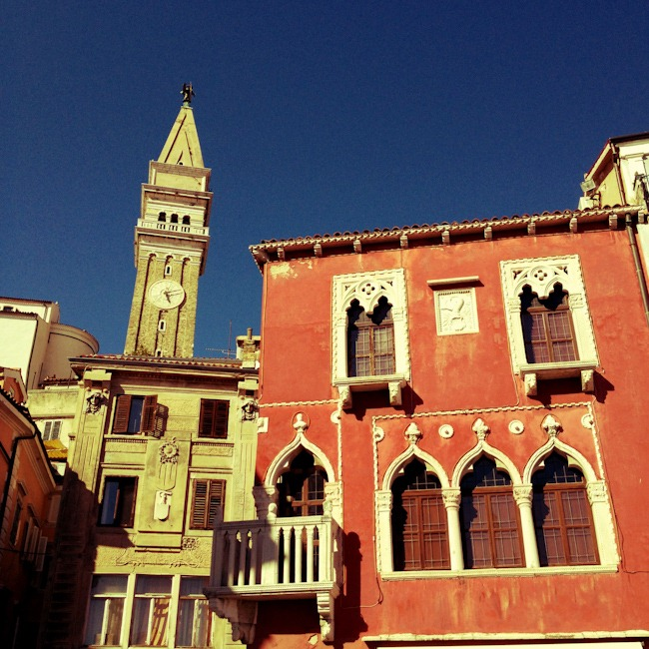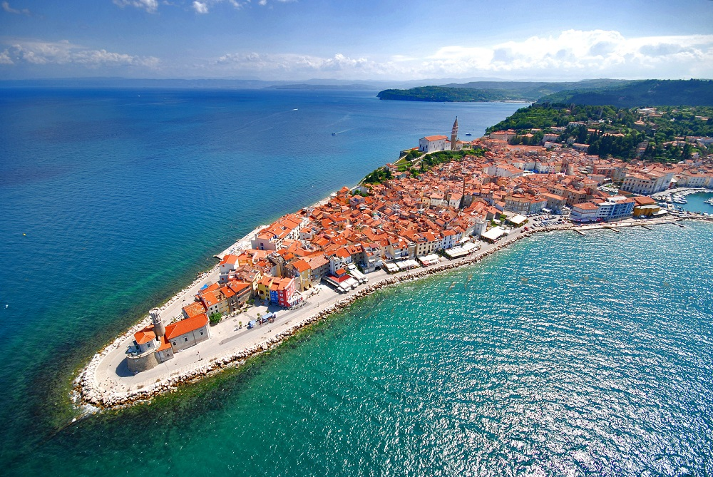

AQUILEIA 25 minutes flight

Aquileia was founded by the Romans as a military colony in 181 BC
Thanks to a good road network and an impressive river port, over time it became increasingly important for its business and for the development of a highly refined crafts (glass, amber, fictilia, gems …). Reached its zenith under the rule Caesar Augustus (27 BC – 14 AD), becoming the capital of X Regio
“Venetia et Histria” and speeding up the process that would have made this one of the most important cities of the Roman Empire.

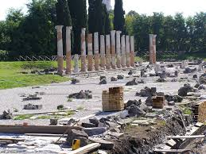

GRADO 20 minutes flight

The Adriatic sea is mainly swept by two winds: the Bora blowing from north-east, cool and dry , and the Sirocco blowing from south-east, warm and wet.
The possibility to orientate the navigation in both directions consented in ancient times the development of the sea connections.

Julius Caesar's ships maintained communications with the legions in Aquileia using the changes of the wind.

The isle of Grado was the first port for these ancient navigators who coming from the isle used to sail up the lagoon and then the river Natissa till Aquileia.

Grado was already famous when Venice didn't exist yet.

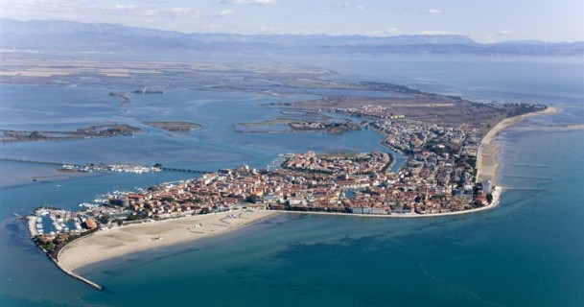

OPTIONAL EXTENSION

Zadar / ZARA from Ravenna 60 minutes flight / from Pola 50 minutes flight

Zara is an ancient Mediterranean port city built on Roman urban principles,
The old town is a treasure trove of archaeological treasures and monuments to the ancient, medieval and Renaissance periods of the venetian time starting from the 13th century until the end of the Republic of Venice.
This is visible by a number of sacral and architectural monuments – the church of sv. Donat [St. Donatus, the Roman Forum near the main square, Kalelarga - the longest and widest street, the Cathedral of sv. Stošije [St. Anastasia], an Archaeological Museum (town gate, Arsenal, churches, museums...).

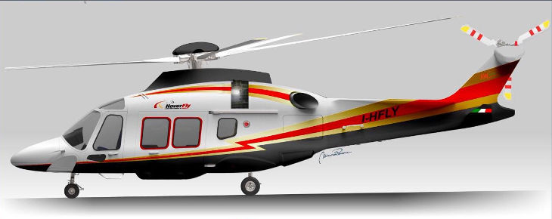

Agusta 109 S Grand

technical specifications

. twin engine
. max speed 160 kts 309 kmh
. range 900 km
. up to 6 passengers on board
. 2 pilots
. IFR equipment to fly in low visibility and bad weather conditions

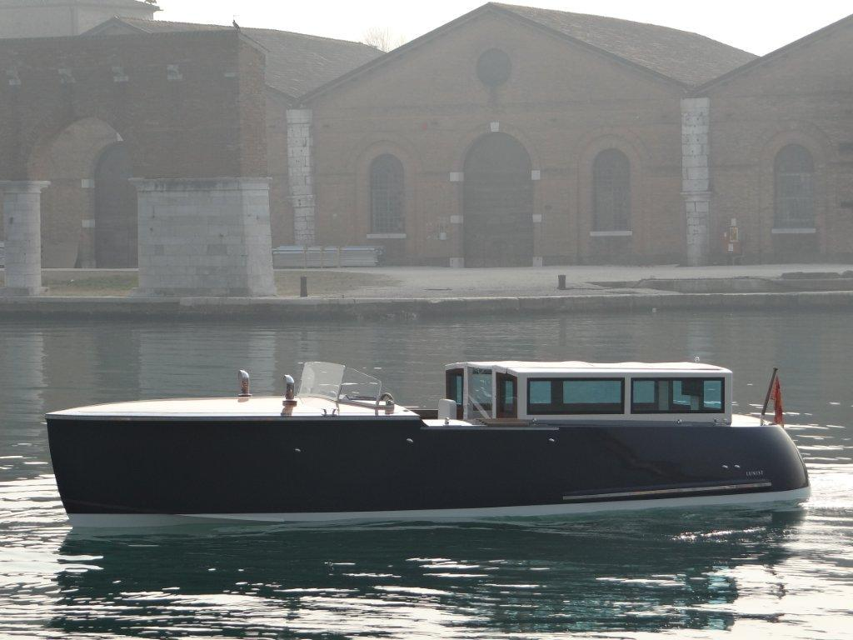

---------------------------------------------------------------------------------------------------------------------------------------------------------------------------------------------------

Info@veniceluxuryguide.com Italy + 39 335 530 4125 USA +1 310 923 0547

www.veniceluxuryguide.com

